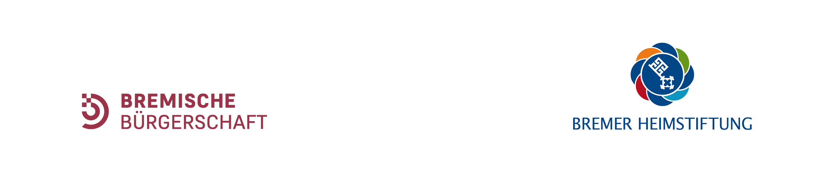

Bremer KUNSTSTIPENDIUM

Art Grant of the City of Bremen

# Application Form

|  |  |
| --- | --- |
| 1. Name: |  |
| 2. First name: |  |
| 3. Permanent address: |  |
| 4. Telephone: |  |
| 5. E-Mail: |  |
| 6. Nationality: |  |
| 7. Date of birth: |  |
| 8. Place of birth: |  |

10. Which language(s) do you speak?

* + German
  + English

11. The following information and materials are required for the application:

* Curriculum Vitae + 1 portrait photo
* List of exhibitions
* Catalogues and texts as PDF files

Or

* 15-20 colour photos with pictures of works from the last 3-5 years plus separate list with designation, date, technique and size, per email

Please sent heavy files (10 MB and above) only via WeTransfer or Dropbox

or

* by a CD-ROM or a stick with CV and pictures, which have to be designated the same way (date, technique, size etc.)

Please send no originals as liability for the submitted material cannot be accepted.

Catalogues cannot be returned after the selection procedure.

Materials for the application per post have to be sent to:

Bremer Kunststipendium

c/o Bremer Heimstiftung, Stiftungsresidenz Landhaus Horn

z.H. Frau Ute Duwensee

Schwachhauser Heerstr. 264

28213 Bremen

For applications by E-mail and further information please contact:

Dr. Katerina Vatsella, Curator of the Art Grant: mail@vatsella.de